**Access Service Report**

**Introduction:**

An access service takes input from client interface and forward the request to their respective services. This is an independent service that is only used for redirecting and retrieving information. Once the service has redirected and retrieved the information, it will send it back to the client as an answer to their query.

An access service is a service at the server side which manages all the get and post requests made to the server and redirect them as required. It is necessary for the server to work correctly and give valid responses, by making an access service we can achieve this. The access service have two main functions handling get request and post requests. We can make the server behave as we want on particular get or post request by access service. It acts as an intermediate to server and client interface.

**UML Diagram:**

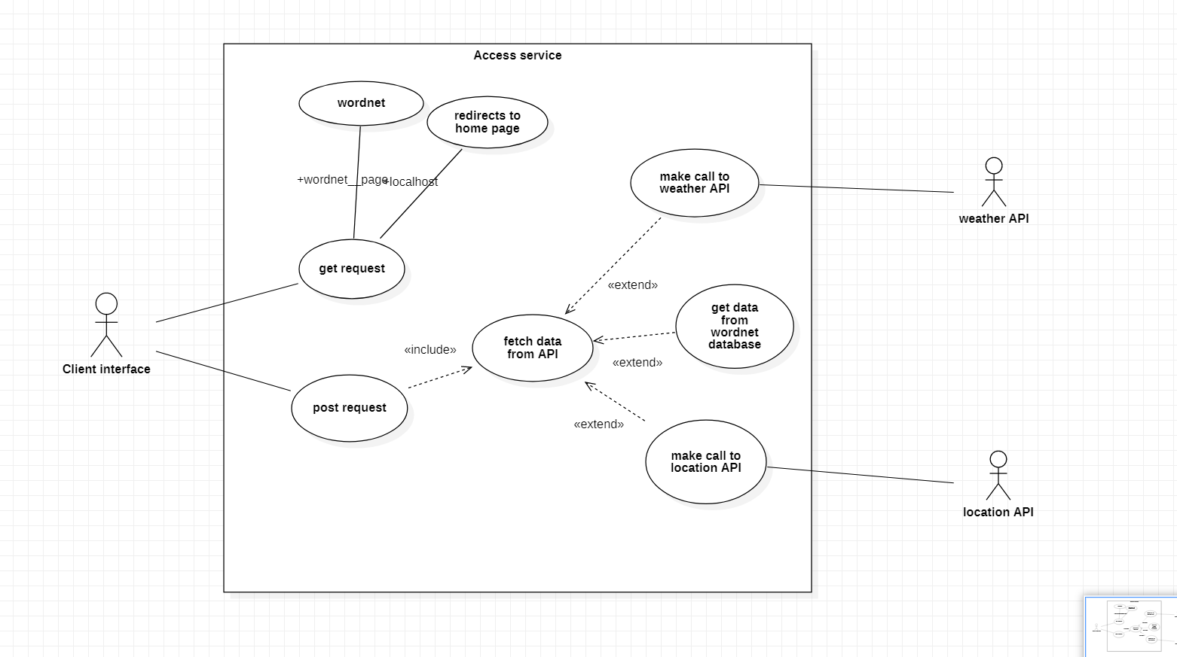

The use case diagram of access service is displayed above . it involves three actors namely client interface, weather API and location API. The wordnet API is not a actor because we have already installed its database in our application server so we don’t have to make a API call to it.

**Client and Server Interaction:**

when the client made any get request then depending upon to which page the get request was made ,we will send the requested page. When the user made any post request then depending upon the type of service selected by the user we will be making API call to respective API. For example , if the user selected weather service then the server will make an API call to weather API and then parse the data received from the API and send it back to the place from where the post request was made.

**References:**

Portion of introduction copied from assignment definition of access service.